SmartRPD — Application Workflow Documentation
Summarised workflow of the live-deployed SmartRPD web application.
Document generated | 2026-08-06
Source commit | d5d5121f12287c45b91d7a0d62acf017d6d98c64 (nyunt/dev-deploy)
Deployed to live site | 2026-08-06T08:55:00Z, build 23, https://faid123.github.io/.tmp-test-web/
Prepared from | Direct source read (git archive of the commit above) — not from memory or the prior .docx bundle
Companion files | flowchart-detailed.mmd.txt, flowchart-summary.mmd.txt (same folder)

Summary flowchart
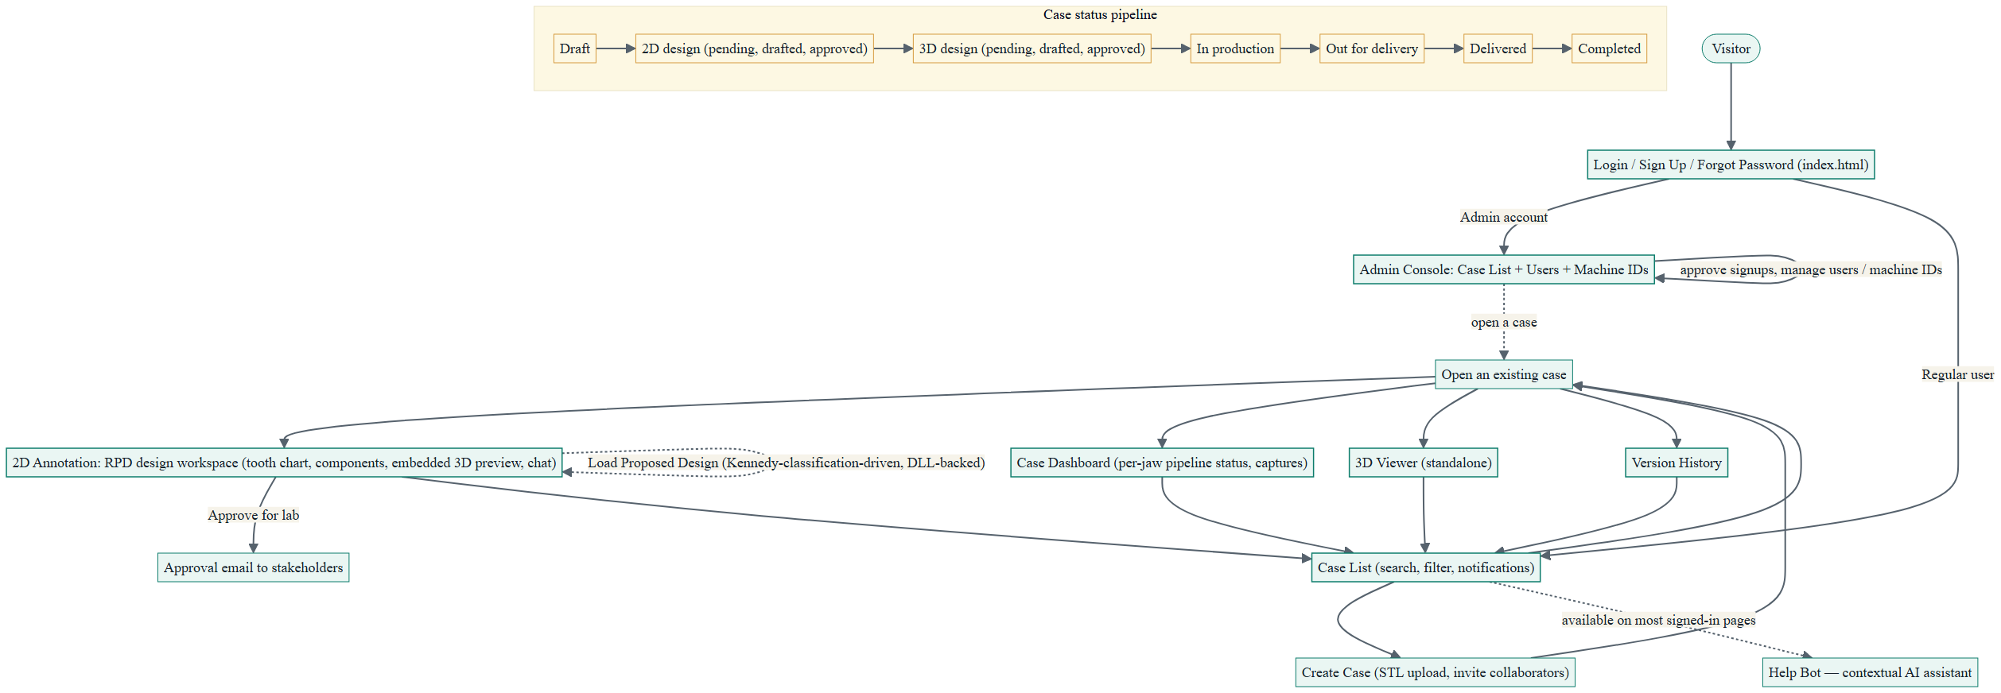
Figure 1 — top-level user journey. Teal = screen/page, amber = the status pipeline. Mermaid source: flowchart-summary.mmd.txt / Appendix B.

1. Summary Workflow
SmartRPD is a web companion to a desktop RPD (removable partial denture) design application. A dental technician logs in, works through a list of cases, and for each case: uploads jaw STL files, designs the RPD framework on a 2D tooth chart, previews/approves the 3D result, and tracks the case through a delivery pipeline. Admins separately manage user accounts, signup approvals, and machine-ID registrations.

1.1 Top-level journey
- Sign in. index.html handles Login, Sign Up (admin-approved), Forgot Password, and a currently-bypassed OTP step. Successful login routes by role.
- Land on a case list. Regular users land on case_list.html; admins land on admin/admin_case_list.html.
- Create or open a case. Creating a case is an inline pane (case name, STL upload, reference images, invite collaborators) — not a separate page.
- Design in 2D. Opening a case goes to 2DAnnotation.html — the RPD framework design workspace, with an embedded 3D preview, chat, and version history alongside it. Opening a case now also offers Load Proposed Design (Kennedy-classification/DLL-driven), not just manual placement.
- Review in 3D / approve. The embedded 3D preview supports survey-angle undercut targeting and an approval flow that emails captured images to stakeholders. A standalone, full-screen 3D Viewer is also reachable from the case list.
- Track status. Each case moves through an 11-step status pipeline from draft to completed, rolled up into three stage groups (Preparation / Delivery / Completed) shown as filter cards.
- Admin manages accounts. A separate admin console approves pending signups, manages users, and manages machine-ID registrations.

